Review of e-Learning Systems Convergence from Traditional Systems to Services based Adaptive and Intelligent Systems

A. M. Riad ¹, Hamdy K. El-Minir ², Haitham A. El-Ghareeb ^{3, Corresponding Author}
^{1,3} Information Systems Department, Faculty of Computers and Information Sciences
Mansoura University, Egypt
amriad2000@mans.edu.eg , helghareeb@acm.org
² National Research Institute of Astronomy and Geophysics
Helwan, Cairo, Egypt
hamdy_elminir2@yahoo.com

Abstract
Service Oriented Architecture (SOA) as a design pattern that presents systems as collection of reusable services that can be exposed and consumed on the Internet with standard interfaces has many advantages that can be achieved on technical, managerial, and implementation aspects of the system. Integrating University Management Information Systems (UMIS) and Learning Management Systems (LMS) can be achieved effectively, efficiently, and with minor modifications of both systems via SOA utilization. SOA can also be useful in integrating long decades and efforts of adaptive and intelligent features of e-Learning in today’s information systems. Both UMIS and LMS; as the two major components of learning information systems can make use of adaptive and intelligent features became available over decades. Adaptive and intelligent features in information systems are many, and they can be utilized in new learning systems. Presenting adaptive and intelligent features as services with standard interfaces will allow different e-Learning systems to adopt them, so they will be reusable and newly introduced information systems will not have to redo the work again, besides, wrapping adaptive and intelligent features with standard interfaces will present a separation of interests that help adaptive and intelligent features’ researchers and developers to focus more on their target and transfer the responsibility of utilizing those features in different information systems to information systems specialists. Today’s e-Learning information systems’ architects can make use of SOA in integrating major e-Learning components together, side by side with adaptive and intelligent features to provide students with personalized learning environment. This article reviews the e-Learning different models and the challenges facing e-Learning nowadays, supposing solution to those challenges. Reviewing the e-Learning proposed systems, architectures, and frameworks starting from traditional e-Learning systems through adaptive e-Learning systems supported by intelligent e-Learning features, methods, and techniques yields e-Learning researchers to Services based Adaptive and Intelligent e-Learning Systems.
Keywords
e-Learning Systems, Adaptive e-Learning, Intelligent e-Learning, Services based Learning Management Systems
- Introduction
E-Learning can be thought of as the learning process created by interaction with digitally delivered content, services, and support. E-Learning involves intensive usage of Information and Communication Technology (ICT) to serve, facilitate, and revolutionize learning process [1, 2, 3]. Learning methods include traditional learning “face-to-face”, distance learning “complete asynchronous time and place learning delivery; mainly online”, and blended learning “learning that combines instruction lead learning with online learning activities leading to reduced classroom contact hours”. Blended learning has the potential to increase student learning while lowering attend rates compared to equivalent fully online courses [4]. Blended learning is the learning paradigm that attempts to optimize both traditional learning and distance learning advantages, potentials, and benefits while eliminating both learning paradigms shortages and challenges. Nowadays blended learning is commonly referred to as e-Learning. When compared to traditional learning paradigm, blended learning is found to be consistent with the values of traditional learning paradigm adopted in almost all higher education learning institutions for decades, and has the proven potential to enhance both the effectiveness and efficiency of meaningful learning experiences [5].
Learning Management System (LMS) is the software that automates the administration of education. LMS registers students, tracks courses in a catalogue, records data from learners, and provides reports to management. LMS is typically designed to handle courses by multiple publishers and providers. It usually doesn’t include its own authoring capabilities; instead it focuses on managing courses created by a variety of other learning resources. Sandy Britain and Oleg Liber present a prototypical LMS in [6]. Because learning models can be classified into traditional, distance, and blended learning paradigms; universities and educational institutions can also be classified into three classes that map to each learning paradigm. However, nowadays technology and the great advancement in recent Web 2.0 and informal learning methods allowed the existence of completed education programs and courses to be presented online. So, university model can be either Online University “full distance learning model”, Campus University “the one that supports either the traditional or blended learning paradigm”. Campus Universities used to have managerial aspects that can’t be neglected and need to be addressed to enable universities to achieve their goals effectively. University Management Information Systems (UMIS) is the software information system responsible for managing universities. UMIS advances LMS with decades. UMIS has achieved mature level of well formed business and performance requirements adoption, and usage. Unlike LMS; which is the newly introduced information system to universities when compared to UMIS. UMIS and LMS needs to be integrated to enable universities present effective and efficient learning.
- Problem Definition
Current Blended Learning Model Paradigm faces many challenges. Those challenges are mainly pedagogical. No one can deny that today’s technologies advances by decades technologies used in teaching and education less than decade ago. However, a number of recent articles have commented that science education is no better today than it was fifty years ago. The National Assessment of Education Progress (NAEP) shows that in most areas today’s students are achieving at about the same levels as students tested in 1971 [7]. E-Learning researchers know very well that this problem is not caused by technology; because as mentioned before technology has advanced greatly. This pedagogical issue is the result of:
- The attempt to use whatever technology currently available or becomes available in the near future without pedagogically considering student or the learning process.
- Allowing technology to stand against the learning process, because no matter what advancement we have achieved, technology is still limiting our dreams (because we still dream about things that we can’t yet achieve technologically), and this situation takes place with e-Learning nowadays.
- The poor evaluation that is available for many of the innovations. Most of the required evaluations are either inadequate or doesn’t exist at all.
Alfred Bork et al. argue that some of the reasons why technology has not led to improvements in learning globally are [7]:
- Grabbing Onto Each New Technology: The belief that each new technology will enhance learning needs more arguments about efficiency than just belief.
- Failure to Continue Successful Development: funders often prefer to look for something new rather than follow up on successful approaches because they want to make a mark by being in the forefront. Funders want to make a statement, and following up on someone else’s work doesn’t provide them with the credit or “name” they desire.
Pedagogically, most training methods and technologies produce, at best, “trained novices”. That is, they introduce facts and concepts to students, present them with relatively simple questions to test this new knowledge, and provide them with a few opportunities to practice using this knowledge in exercise or scenarios. However, becoming proficient requires extensive proactive solving realistically complex problems in wide range situations, combined with coaching and feedback from managers, more experienced peers, or other types of experts [8].
Most evaluations of today’s presented technologies in the learning model focus on technology aspects of the solution while ignoring the pedagogical aspect; almost at all. The result of using technology, particularly computers, in learning has so far not been impressive. A variety of studies and opinions have questioned the use of technology to improve learning. Although it has been many years since computers have begun to be used in learning environments, there is little improvement in learning, with or without technology. Although the use of technology in learning shows no significant difference, that is, computer learning is no better than traditional instruction, learners have been provided with the convenience of any time, any place learning. Students’ understand and retention improves when students learn by experience. Technologies such as collaboration, interactivity, modelling, simulations, virtual reality interfaces, and gaming will help students experience the skill being taught, but they have not helped students that far yet [7]. Besides, students lack of awareness of different e-Learning technologies stand up against the presentation of effective e-Learning model.
- Proposed Solution
Adaptive learning for students with many different backgrounds, learning styles, and interest is almost a must. Educational psychologists by and large agree that students differ greatly in the ways they learn and very few teachers or professors can adapt learning to each student in the typical large classes, the costs associated with delivering different instruction for varied learning styles is prohibitive [7]. Benjamin Bloom (1984) showed twenty-five years ago, as reported in his 2 sigma paper, that almost all students can learn to the mastery level, given the right learning environment [9]. In Bloom’s experiments, the most successful learning strategy was tutoring. Adaptive e-Learning that is supported with intelligent techniques and methods is one of the ways to support personalized e-Learning, and so authors believe that it will be the way to solve many of the limitations and today’s e-Learning challenges. Authors will review the different adaptive and intelligent e-Learning systems proposed over a long e-Learning research era, highlighting the maturity of adaptive and intelligent features and the e-Learning researchers attempt to introduce services based e-Learning systems in order to overcome many of the e-Learning challenges, like reusability, scalability, integration, and interoperability. Finally, authors will conclude with the need to present a new learning model that attempts to use the best of what was presented before, and avoid all the challenges and mistakes. Though authors believe there’s no single unified learning model can be the only right model, hopefully this work will be a step towards a better learning model supported with the appropriate technologies.
- Adaptive e-Learning Systems
Computer-based learning systems are criticized by many researchers for their limited ranges and adaptability of teaching actions compared to rich tactics and strategies employed by human expert teachers [10]. Many universities in the developing countries, started to adopt e-Learning by modifying their network infrastructure, establishing new labs, providing internet connection, and purchasing different tools for creating e-Learning courses and using different LMSs. However, these modifications and supplement were not enough to ensure successful e-Learning outcomes because other important elements for e-Learning success were missing such as flexibility of the system, adaptability towards students needs, reusability of learning objects, interoperability between different LMSs, effective and official design of e-content [11].
Adaptive e-Learning systems would be a good solution for better e-Learning. The absolute majority of Web-enhanced courses rely on LMS because they are powerful integrated systems that support a number of teachers and students needs. Though LMSs look surprising, indeed for every function that a typical LMS perform there is an Adaptive Web Based Educational System (AWBES) that can do it much better [12]. Adaptivity is the ability to modify e-Learning lessons using different parameters and a set of predefined rules. Researchers differentiate slightly between adaptivity and adaptability by thinking about adaptability as the possibility for learners to personalize an e-learning lesson by themselves. These two approaches go from machine centred (adaptivity) to learner centred (adaptability). In practice, it is quiet difficult to isolate one from the other due to their close relationship [13, 14]. Adaptive e-Learning is often meant to be new or in an early development stage [10]. Christian Gutl defines adaptive e-Learning systems as an environment of software modules, which comprises a set of features for adaptivity and adaptability [15]. Important factors for adapting to student needs and desires include [7]:
- Each Student Should Move at a Unique Pace: Given all the variations between student backgrounds, interests, and abilities, it is highly desirable to allow each student move at a unique pace in the learning units.
- Adaptation Should be Very Frequent: Changes based on occasional exams are inadequate. Learning activities should adapt to each student on a moment-by-moment basis. Students should feel that the adaptive program is responding to them as individuals.
- Each Student Should Be Successful in Learning: a major advantage of adaptive variable placing is that the students can continue to learn in a given area until they have learned the material. We know from Bloom’s research that almost all learners can succeed and achieve mastery, but some learners need more time and more practice than others.
- When Something Is Successfully Learned, the Learner Should Move On: Often in classroom learning, after a student has learned something, the class continues working on the topic, boring the student. This will not occur in a fully adaptive learning environment.
- No One Should Be Taught Something S/he Already knows: By assuring learner competencies, avoiding unneeded instruction, and moving each student forward when ready, we expect to achieve a major reduction of learning time, but this cannot be verified empirically until we have a full range of computer-based adaptive learning units.
The provision of static learning material will not meet the requirements of the users. Adaptive
e-Learning enables personalizing learning process to individual learners via adapting some parameters; like identifying, analyzing and monitoring relevant aspects of instructions, such as different velocities, paths, or strategies of learning can be personalized. Performance improvements within the learning process can be gained via adaptive e-Learning systems [15]. Adaptation and personalization will improve the learning process, therefore, a paradigm shift from the consumption of static learning contents to well tailor and highly personalized learning sessions is needed.
  - Adaptive e-Learning Approaches
Four main approaches which are used to give a historical overview of adaptive e-Learning can be identified [10]:
- Macro-Adaptive Approach: Addresses adaptation of instructions on a macro-level by allowing different alternatives in selecting a few main components such as learning objectives, levels of detail, delivery system, etc. In this approach, instructional alternatives are selected mostly on basis of the student’s learning goals, general abilities, and achievement levels in the curriculum structure.
- Aptitude-Treatment Interaction (ATI) Approach: This approach treats adaptation of instructional strategies to specific student’s characteristics. This strategy proposes different types of instructions or even different media types for different students. The most important classes of learner characteristics can be summarized with the following ones: intellectual abilities, cognitive styles, learning styles, prior knowledge, anxiety, achievement motivation, and self-efficiency. One aspect of the ATI approach is the user’s control over the learning process according to the abilities of the students by giving them full or partial control over the style of the instruction or the way through the course. Level of control can be one of three levels: complete independence, partial control within a given task scenario, and fixed tasks with control of pace.
- Micro-Adaptive Approach: Addresses adaptation of instructions on a micro-level by diagnosing the student’s specific learning needs during instruction and providing instructional prescriptions for these needs. Researchers have attempted to establish micro-adaptive instructional models using on-task rather than pre-task
measures. Monitoring the user’s behaviour and performance, such as response errors,
response latencies, emotional states, etc. can be used for optimizing instructional treatments and sequences on a very refined scale [15].
- Constructivistic-Collaborative Approach: Follows the constructivist pedagogical approach. An important element of this approach is the usage of collaborative technologies which are considered often on essential component of e-learning. Adaptive system enables learning by focusing on how knowledge is learned and should consider the context, learning activities, cognitive structures of the content, and the time extension. Some new adaptive e-learning systems take account of students’ motivational factors combining the instructional plan with a “motivational” plan.
Over the last decades, various types of adaptation systems and possible areas for their applicability have been identified, thus leading to the emergence of specialized research fields, like Adaptive Hypermedia Systems (AEHS), Computer Aided Instruction (CAI), Computer Managed Instruction (CMI), Recommender Systems, Intelligent Tutoring Systems (ITS), Personalized Systems of Instruction (PSI), and many others. Adaptive multimedia systems as an improved learning environment is well documented in the research work of Christian Gutl et al. [15].
  - Adaptive Educational Hypermedia Systems (AEHS) Overview
Brusiolvsky thinks about Adaptive Hypermedia Systems as systems that refer to all hypertext and hypermedia systems which reflect some features of the user in the user model and apply this model to adapt various visible aspects of the system to the user. In other words, the system should satisfy three criteria: it should be a hypertext or hypermedia system; it should have a user model; it should be able to adapt the hypermedia using this model [14].
    - Application Areas of AEHS
Educational Hypermedia Systems are the most popular area for adaptive hypermedia research and incorporates applications like:
- Adaptive Textbooks: Adaptive Textbooks use history-based, knowledge-based and prerequisite-based adaptive annotation of links to suggest to the individual user an appropriate path through a learning space by adapting the navigation links [16]. Adaptive textbooks can help students learn faster and better [12].
- Adaptive Quizzes: Quizzes and Tests are assembled by the system from a pool of questions using student and domain models that are manipulated with automated reasoning machines. Such forms of evaluation are adaptive in a per- question basis. Also it would be desirable to have the questions themselves be adaptive [17].
- Adaptive Class Monitoring: Class Monitoring tools are important to give the teacher much better chances to notice the students lagging behind [12]. Adaptive Teaching Systems can help instructors adapt lectures and educational contents to fit students.
- Adaptive Collaboration Support: Intended to capture adaptive support in learning processes that involve communication between multiple persons (and, therefore, social interaction), and potentially, collaboration towards common objectives. Adaptive techniques can be used in this direction to facilitate the communication/collaboration process, ensure a good match between collaborators, and other activities [18]. Adaptive Collaboration Support can enforce the power of collaborative learning [12].

    - Modeling the User
Three categories of user related data can be defined and modelled in AEHS [14,19]:
- User Data: Refers to information about personal/characteristics of the user. User features that can be stored in AEHS include knowledge, goals/tasks, background, hyperspace experience, preferences, interests and individual traits, and cognitive and learning styles.
- Usage Data: is related to information on the user's interactive behaviour that cannot be resolved to user characteristics. This category include data like: selective actions of the user (clicking on links, scrolling and enlarging operations for hypermedia objects, audio control operations), temporal viewing behaviour rating (users are required to explicitly rate objects, links, WebPages), and purchases and purchase-related actions.
- Environment Data: comprises aspects of the user environment that are not related to the users themselves. This kind of adaptation has evolved due to Web-based systems. Adaptation decisions may depend on spatial-temporal location of the user, the user platform (such as hardware, software, equipment - computer, PDA, cell phone, digital TV), and network.

    - Adaptation Taxonomy
In 1996 Brusilovsky developed a taxonomy providing a way to segment adaptive research into two categories, which was labelled “adaptive presentation and adaptive navigation support” [20]. Figure 1 shows an updated taxonomy of adaptive hypermedia technologies [21]. This taxonomy has been illustrated and studied by many researchers [14,22]. Whereas the adaptive presentation changes the content presented in the documents, the adaptive navigation support changes the structure of links between the documents and how this navigation structure is presented to the user.

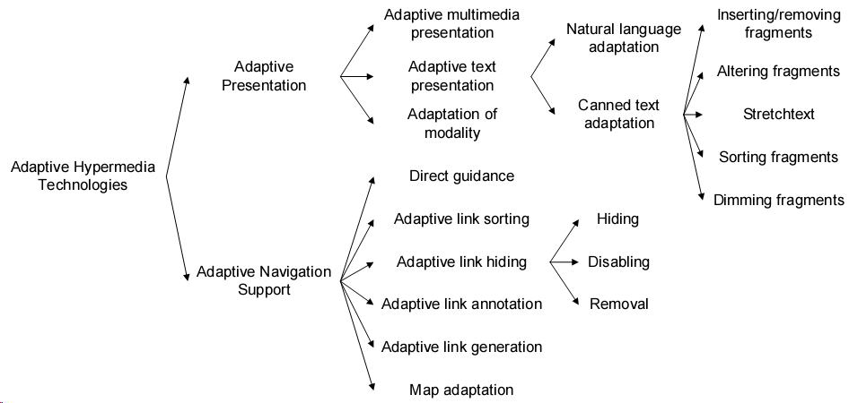
Figure 1. Updated Taxonomy of Adaptive Hypermedia Technologies [21]

      - Adaptive Presentation
The goal of adaptive presentation is to adapt the content of a hypermedia page to the user’s goals, knowledge and other information stored in the user model. This area concerns the selection and composition of information fragments to be later presented to the user. For example, the system may decide to provide additional explanations as well as to hide content from a novice user, while an expert user in the domain will receive more specific and more detailed information. In a hypermedia system the content of a “page” may not only be text, but it may also contain various items of other media types. The main benefit of the adaptive presentation is that it tries to reduce the amount of presented information to the most relevant information for a particular user, solving the “information overload” problem of the classic hypermedia systems.
- Adaptive Multimedia Presentation: the selection of different multimedia fragments (in practice this technique also includes the adaptation of multimedia content, just as the generation of shortened versions, but currently most examples of adaptive multimedia simply select between prefabricated content).
- Adaptation of Modality: choice among different types of media to present to the user, related to the same content; e.g., for a video we can have full video, still image, text description, or use of them in parallel.
- Adaptive Text Presentation
  - Natural Language Adaptation: Natural language adaptation cannot be classified further at the moment. Many natural language generation systems do, in fact, make use of fragments (and even paragraphs) of canned text, but distinction here is made between those systems that use natural language technology as a foundation and those that do not. Refinement of this distinction might be needed at a later stage.
  - Canned Text Adaptation: This term includes fragment processing, such as:
    - Inserting / Removing Fragments: Information related to a concept is broken into several fragments of text (or multimedia content). With each fragment a condition is associated on elements of the user model. When information related to a concept is presented, the system selects only those fragments for which the condition is true. This technique can be used to implement the methods of additional, prerequisite and comparative explanations.
    - Altering Fragments: Can be used for the implementation of the explanation variants method. The AEHS stores several variants of the same information fragment, and selects the variant to display based on the user model. For example, each variant is created for different group of users such as beginner, intermediate, and expert.
    - Stretch Text: Fragments are embedded in a webpage and initially shown or hidden from the user depending on conditions on user model data. AEHS can show or hide these fragments also upon explicit user requests. This technique is useful for implementing additional, prerequisite or comparative explanations, but less for explanation variants and not all for sorting.
    - Sorting fragments: This technique is used for the sorting method and presents a set of fragments to the user, ordered from the most relevant to the least relevant according to some criteria based on user’s goal, background, knowledge, etc.
    - Dimming fragments: Used to dim, shade or deemphasize (in some way) a fragment to indicate that it is not (or at least less) relevant for the user.

      - Adaptive Navigation Support
Adaptive Navigation Support modifies or augments the existing set of hyperlinks shown to the user to aid them in finding relevant information with the goal to help users find their way through hyperspace by adapting link presentation and functionality to the goals, knowledge, and other characteristics of an individual user. The goal is to guide the user towards relevant and interesting information and to advise the user not to follow navigation paths that lead to irrelevant information. The main benefit of the adaptive navigation support is that it simplifies the rich link structure and solves the “lost in hyperspace” problem while maintaining the navigation freedom that is typical of hypermedia systems. Adaptive navigation support contains several different techniques that can be used individually or combined to provide navigational support:
- Direct guidance: AEHS outlines visually one of the links on the page showing that this is the best link to follow or generates an additional dynamic link which is connected to the recommended “next” page to visit.
- Adaptive Link Sorting: AEHS uses sorting mechanisms; like ordering links from most relevant to lowest relevant to recommend links to users.
- Adaptive Link Hiding/Disabling/Removing: AEHS tries to prevent the user from following links that are not relevant at the moment. There are several ways to achieve this goal. A link can be hidden by changing the color of the anchors to that of normal text or removing the anchor. Also, link functionality can be disabled and so the link is removed.
- Adaptive Link Annotation: AEHS augments the links with some form of comment, which can tell the user more about relevance of the nodes behind the annotated links. These annotations are usually provided in the form of visual cues such as icons, font colors, sizes, and types.
- Adaptive Link Generation: AEHS may discover new useful links between pages and add them by using previous navigation (by an individual user or a user group) or page similarity to add links.
- Map Adaptation: This technique consists of a combination of the other techniques, the only difference being that it is applied to a graphical visualization of the navigation structure. The map is usually presented in a separate frame or window.

    - Adaptive and Intelligent Educational Hypermedia Systems (AIEHS) Overview
Enhancing AEHS with methods and techniques from Intelligent Tutoring Systems (ITS) creates the AIEHS. ITSs form an advanced generation of Computer-Aided Instruction (CAI) systems with their ability to provide a user-adapted presentation of the teaching material. ITSs have been developed and evaluated for many years in the field of artificial intelligence in education. The emergence of WWW increased the usefulness of such systems. Web-based learning systems should be more intelligent through adoption of artificial intelligence techniques [1]. Intelligent e-Learning systems include utilizing artificial intelligence techniques, such as decision making, machine learning, planning, scheduling, and cognitive science in e-Learning platforms [23]. The objective of intelligent e-Learning systems, as is typically conceived, is to provide highly structured lessons that are to a large extent under automated control. Within this framework, the intelligence of the system often appears in the form of adaptive, sequencing or personalization of the course material, adaptive guidance for navigation, or interactive problem solving support. The most interesting opportunities to develop intelligent functionality are related to facilitating collaboration rather than adapting the learning material [24]. There has never been a clear distinction between intelligent and adaptive e-Learning systems. AI techniques have been widely used to support adaptive e-Learning features. Christopher Paul Bailey presents an agent-based framework to support adaptive hypermedia [25].
  - Examples of Real World Adaptive
e-Learning Applications
N. Matar et al. presented what they called “adaptive e-Learning system” to address different adaptive features of e-Learning [11]. N. Matar et al. argued that the proposed system can help universities; especially newly established ones come over limitations and shortages by presenting a global course repository. Despite the obstacles that can come against such a solution; starting from the required infrastructure and ending with the instructors’ choice to refuse submitting the learning material they have created, centralization as a solution is not the most suitable solution anymore. A. M. Riad and Haitham A. El-Ghareeb argues that shareability among different LMSs is the solution to unlock course repositories and presented a SOA based CMS that integrates different LMSs [26]. Besides, N. Matar et al. talked about the ‘Unified Adaptive e-Learning System’ as the proper solution to adaptive e-learning implementation ignoring the fact that adaptive e-Learning solutions doesn’t come in the ‘one solution fits all scenarios’. Adaptive e-Learning solutions differ from different cultures, and different learning scenarios. Instead of attempting to unify adaptive e-Learning, integrating different adaptive e-Learning modules together to establish an adaptive upon request e-Learning solution is the best solution.
- Intelligent e-Learning Systems
Artificial Intelligence (AI) utilizes programming algorithms to simulate thought processes and reasoning that produce behaviour similar to humans. A successful implementation of AI could be tested using a Turing Test approach, in which a human interacts with an interface that could have either a human or computer on the other end. The test is considered successful if the human is unable to determine whether there is a computer or a human on the other end. The applications of AI within e-learning can produce the potential of creating realistic environments with which students can interact. The student essentially would interact with the intelligent agents which in turn perceive changes in the simulated environment. The intelligent agents would then communicate perceived changes in the environment back to the student who then makes decisions based upon their own perceptions of the environment [27].
Current learning technologies can help create trained novices more efficiently, but they are really not up to the job of creating true experts. For example, multimedia Computer Based Training (CBT) systems are good at presenting information and then testing factual recall using multiple choice or fill-in-the blank questions. However, traditional CBT systems are incapable of providing intelligent, individualized coaching, performance assessment, and feedback students need to acquire broad and deep expertise [8].
Employing the state-of-the-art artificial intelligence (AI) technology in current e-learning systems can bring personalized, adaptive, and intelligent services to both students and educators. Although we have seen more and more successful applications of AI in e-learning, most of them have not yet been expanded to or adopted in widely used e-learning systems, especially open-source learning management systems (LMS) such as Moodle, Sakai and so on. This observation takes us to the analysis and discussion of the current work in both LMS and applied AI. The findings include that current intelligent LMS systems are still in their early stage, while AI applications need to handle some problems or to be modified before applying them into the LMS systems, and AI technology also needs to be brought to open source communities [28].
  - Evolution of AI in e-Learning
Koschman views the evolution of Computer Based Instruction (CBI) as a series of paradigmatic shifts in the field of Instructional Technology. According to Koschman, the initial CBI paradigm, entitled Computer-Assisted Instruction (CAI) emerged in 1960 with the release of Coursewriter I [29]. Koschman argues that the next paradigm shift – Intelligent Tutoring Systems (ITS) – was founded by members of the AI community who had migrated to the educational community. Their motivation was as follow:
“Research in AI is founded upon the conjecture that cognition is, in some sense, a computational process than can be studied through the construction of “intelligent” systems that serve as functional models of the otherwise inaccessible processes of the human mind. If machines can be programmed to display intelligent behaviour, there is no reason, at least in principle, that systems could not be designed to assume the role of a skilled teacher. Since one-on-one tutoring is commonly considered the gold standard against which other methods of instruction are measured, the paradigm is founded on the proposition that education could be globally improved by providing every student with a personal (albeit machine-based) tutor” [29].
  - AI Methods and Techniques
AI methods and techniques enable computer programs and software applications to think and act intelligently and rationally. To achieve this goal, AI utilizes methods and techniques, like: Neural Networks, Genetic Algorithms, Reinforcement Learning, and Fuzzy Logic.
    - Neural Networks
Neural Networks do not rely on ruled-based programming for their performance. Instead, neural networks use learning algorithms to “tune” outputs to inputs. The technology finds use in situations in which rules are not explicitly available, and in which “tuning” inputs to outputs is easier than analyzing the internal reasoning process. Currently, data mining uses neural networks to analyze the large volumes of data [30]. J.E. Villaverde et al. presents a feed-forward neural network to recognize automatically the learning styles of individual students according to the actions that he or she has performed in an e-learning environment [31].
    - Genetic Algorithms
Genetic Algorithm is the population containing a number of trial solutions each of which is evaluated to yield fitness and a new generation is created from the better of them. The process is continued through a number of generations with the aim that the population should evolve to contain an acceptable solution. Mu-Jung Huang et al. presents an approach to adaptive e-Learning based system that utilizes Computerized Adaptive Testing to identify the learner applicability for a learning topic, and then the Genetic Algorithm and Case-Based Reasoning (CBR) are employed to construct an optimal learning path for each learner. Mu-Jung Huang et al. presented a genetic-based curriculum sequencing approach that will generate a personalized curriculum sequencing [32]. Anna Hovakimyan et al. presents another Genetic Algorithm based e-Learning system that is based on so called “teaching-scenario” and capable of creating the appropriate sequence of the teaching resources from the set of all possible teaching resources based on quantity and quality [33].
    - Fuzzy Logic
Fuzzy set theory provides a formalism in which the conventional binary logic based on choices "yes" and "no" is replaced with a continuum of possibilities that effectively embody the alternative "maybe". Formally, the characteristic function of set X defined by f(x) =1 for all x in X and f(x)=0 for all x not in X is replaced by the membership function. J. Vrettaros et al. presents a fuzzy logic based correction tool that can be utilized in e-Learning systems. Test correction tool utilizes fuzzy logic rules in classifying students based on their answers and rigidity of correction levels [34]. Y. Chen uses feedback and fuzzy self-organizing map to improve adaptive e-learning model via continuously updating teaching material by tracking learner grades and achievement level [35]. K. K. Loo presents genetic algorithm utilization in SmartTutor that can identify the weaknesses of a learner in an e-course and advice the learner how to do revision efficiently [36].
  - Software Agents as Major AI Implementation
Software Agent is a program that performs some information gathering or processing task in the background. Typically, an agent is given a very small and well-defined task [37]. Software Agent is a physical or virtual entity which:
- Is capable of acting in an environment.
- Can communicate directly with other agents.
- Is driven by a set of tendencies (in the form of individual objectives or of a satisfaction/survival function which it tries to optimize).
- Possesses resources of its own.
- Is capable of perceiving its environment (but to a limited extent).
- Has only a partial representation of its environment (and perhaps none at all).
- Possesses skills and can offer services.
- May be able to reproduce itself.
- Its behavior tends towards satisfying its objectives, taking account of the resources and skills available to it and depending on its perception, its representation and the communications it receives.
    - Software Agents Characteristics
Agents are capable of acting, not just reasoning. Actions affect the environment which, in turn, affects future decisions of agents. The main attributes and characteristics of Software Agents are [37]:
- Autonomy: A key property of agents is autonomy. They are, at least to some extent, independent. They are not entirely pre-programmed but can make decisions based on information from their environment or other agents. agents have capabilities of task selection, prioritization, goal-directed behavior, decision-making without human intervention
- Mobility: Although this property is optional, it certainly characterizes some agent systems. It is interesting to note that in the natural world, agent intelligence is always associated with agent mobility (animals). Other living things (plants) have no intelligence.
- Persistency: code is not executed on demand but runs continuously and decides for itself when it should perform some activity.
- Social ability: agents are able to engage other components through some sort of communication and coordination; they may collaborate on a task.
- Reactivity: agents perceive the context in which they operate and react to it appropriately.
An agent is an encapsulated computer system that is situated in some environment and that is capable of flexible, autonomous action in that environment in order to meet its design objectives. Software Agents are [38]:
- Clearly identifiable problem-solving entities with well defined boundaries and interfaces.
- Situated (embedded) in a particular environment; they receive inputs related to the state of their environment and they act on the environment through effectors.
- Designed to fulfill a specific purpose; they have particular objectives (goals) to achieve.
- Autonomous; they have control both over their internal state and over their behavior.
- Capable of exhibiting flexible problem solving behavior in pursuit of their design objectives; they need to be both reactive (able to respond in timely fashion to changes that occur in their environment) and active (able to act in anticipation of future goals).
    - Intelligent Software Agents
Intelligent Agent is a software agent that exhibits some form of artificial intelligence. While the working of software agents used for operator assistance or data mining (sometimes referred to as bots), are often based on fixed pre-programmed rules, "intelligent" implies the ability to adapt and learn.
- Ability to Adapt: Adaptation implies sensing the environment and reconfiguring in response. This can be achieved through the choice of alternative problem-solving-rules or algorithms, or through the discovery of problem solving strategies. Adaptation may also include other aspects of an agent's internal construction, such as recruiting processor or storage resources.
- Ability to Learn: Learning may proceed through trial-and-error, then it implies a capability of introspection and analysis of behavior and success. Alternatively, learning may proceed by example and generalization, then it implies a capacity to abstract and generalize.
In some literature IAs are also referred to as “autonomous intelligent agents” [39], although autonomy is generally assumed for agents. IA systems should exhibit the following characteristics:
- learn and improve through interaction with the environment (embodiment)
- adapt online and in real time
- learn quickly from large amounts of data
- accommodate new problem solving rules incrementally
- have memory based exemplar storage and retrieval capacities
- have parameters to represent short and long term memory, age, forgetting, etc.
- be able to analyze itself in terms of behavior, error and success
    - Software Agents Challenges
When several agents (inter)act they may form a multi-agent system. Characteristically such agents will not have all data or all methods available to achieve an objective (this can be referred to as "limited viewpoint") and thus will have to collaborate with other agents. Also, there may be little or no global control and thus such systems are sometimes referred to as swarm systems. As with distributed agents, data is decentralized and execution is asynchronous. Earlier, related fields include Distributed Artificial Intelligence (DAI) and Distributed Problem Solving (DPS).
Multi-Agent architecture standards were attempted in order to force MAS standardization and global integration. Knowledge Query and Manipulation Language (KQML) was presented in order to support knowledge sharing among agents [40]. Knowledge Interchange Format (KIF) is a computer-oriented language for the interchange of knowledge among disparate programs developed by the ARPA-sponsored Knowledge Sharing Effort [41]. The OMG group proposed a reference model as an attempt to standardize the development of agent technologies [42]. KAoS is described as "an open distributed architecture for software agents.'' The KAoS architecture describes agent implementations (starting from the notion of a simple generic agent, to role-oriented agents such as mediators and matchmakers), and elaborates on the interactive dynamics of agent-to-agent messaging communication by using conversation policies [43]. The Foundation for Intelligent Physical Agents (FIPA) is a multi-disciplinary IEEE standardizing group pursuing the standardization of agent technology. FIPA's approach to MAS development is based on a "minimal framework for the management of agents in an open environment'' [44]. Unfortunately, as a result for all the standardization effort, there were no universally accepted commercially supported standard yet.
    - Software Agents based e-Learning Systems
Utilizing Software Agents in e-Learning systems have been known to e-Learning researchers very well. Alfredo Garro and Luigi Palopoli [45] proposes an XML based Multi-Agent System to support Chief Learning Officers in defining roles, associated competencies and knowledge level required; manage the skill map of the organization; measure human resources competence gaps; support employees in filling their competence gaps as related to their roles; enrich a given courseware or create personalized learning paths according to feedbacks user provides in order to optimize the acquisition of needed competencies; and assist Chief Learning Officers in choosing the most appropriate employee for a given role. A strong well presented utilization of Multi Agent Systems in performing different tasks.
Using software agents as recommenders to students has been presented by O.R. Zaiane [46]. Zaiane presented a recommender system in an e-learning context that tries to "intelligently" recommend actions to a learner based on the actions of previous learners. This recommendation could be an on-line activity such as doing an exercise, reading posted messages on a conferencing system, or running an on-line simulation, or could be simply a web resource. The use of web mining techniques to build such an agent that could recommend on-line learning activities or shortcuts in a course web site based on learners' access history to improve course material navigation as well as assist the online learning process was presented.
  - Intelligent Tutoring Systems
In the early 1970s a few researchers defined a new and ambitious goal for computer-based instruction. They adopted the human tutor as their educational model and sought to apply Artificial Intelligence techniques to realize this model in “intelligent” computer-based instruction [47].
Intelligent Tutoring Systems (ITSs) are complex, integrated systems that apply Artificial Intelligence (AI) techniques to problems of education and training. ITS uses Artificial Intelligence techniques to customize instructions according to the student’s needs. ITSs strive to optimize learning of domain concepts and problem solving skills by means of adaptive, individualized coached practice on domain tasks [48].
The goal of ITSs would be to engage the students in sustained reasoning activity and to interact with the student based on a deep understanding of the students’ behaviour. If such systems realize even half the impact of human tutors, the payoff for society promised to be substantial [47].
The closest computational analogy to an ITS is an expert system, while the closest educational analogy is a Computer-Assisted Instructional (CAI) system [49]. ITS can be thought of as Intelligent Computer Aided Instruction (ICAI). ITS is an educational software containing an artificial intelligence component. The software tracks students' work, tailoring feedback and hints along the way. By collecting information on a particular student's performance, the software can make inferences about strengths and weaknesses, and can suggest additional work.
    - ITS Modules
ITS rely on three types of knowledge, organized in three separate software modules namely Domain, Pedagogical, and Student modules as depicted in figure 2 [8,48].
- Domain Knowledge Base Module: is the set of questions being taught. Represents subject matter expertise and provides the ITS with knowledge of what it is teaching. This module let the ITS know what it is teaching.
- Pedagogical Modules: contains the methods of instruction and how the knowledge should be presented to the student, enables ITS to know how to teach, by encoding instructional strategies used by the tutoring system. This module lets the ITS know how it is teaching.
- Student Module: Represents the student’s knowledge, skills, and other attributes that affect how the student should be taught. This module lets the ITS know who it’s teaching.
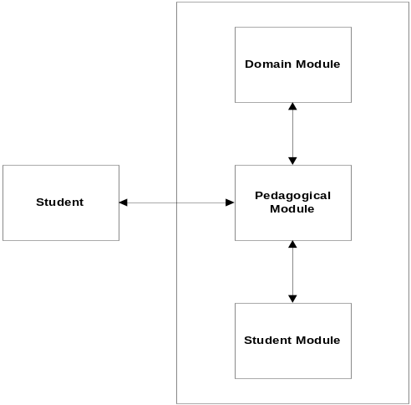
Figure 2. ITS Block Diagram
    - ITS Limitations and Challenges
A variety of AI techniques are used to capture how a problem can be solved. Major ITS systems capture subject matter expertise in rules. Though rules enables ITS to generate problems on the fly, combine and apply rules to solve the problems, assess each learner’s understanding by comparing the software’s reasoning with theirs, and demonstrate the software solutions to the participant’s, B. H. Sreenivasa Sarma and B. Ravindran argues that Rule based ITS challenges include [48]:
- There are many rules which a system can use to teach efficiently, but which are very difficult to encode.
- It is difficult to incorporate the knowledge that human teachers use, but cannot express. The machine tutors have a different set of data available than the human tutors, so the knowledge that could improve the tutor’s performance is ignored.
- Rule-based systems are not adaptive to new student’s behavior.
While there has been a sustainable research effort in the application of artificial intelligence to education over the past three decades with some notable success stories, intelligent tutoring has had relatively little impact on education and training in the world. There are several reasons for this lack of penetration [47]:
- ITSs are expensive to develop and until relatively recently, the necessary computing power was expensive to deploy.
- Ontogeny of the field and the consequences for software evaluation. The creative vision of intelligent computer tutors has largely arisen among artificial intelligence researchers rather than education specialists

    - Examples of ITSs
Edward R. Sykes and Franya Franek present a Web-Based Architecture of an Intelligent Tutoring System for Remote Students Learning to Program Java that is called JITS [50]. JITS utilizes an Intelligent Module to define errors at student submitted code. Student code is passed to Java Parser; that checks student code for errors. When errors found, a fuzzy logic based semantic engine is used to define error spots and notify students to correct them, and the process takes place till code is verified. Besides, JITS contextually offers students’ help by giving hints about the proper programming method that shall be used (for example: for loop instead of if-then statement). JITS is a Web-based solution that utilizes distributed architectural components. Most ITSs lack evaluation results; and JITS is one of them. Though JITS utilizes Web based architecture, it is always a challenge to integrate Agents based systems with external systems. It is believed that this integration challenge limits the widespread utilization and usage of software agents in real life world scenarios.
- Utilizing Service Oriented Architecture in e-Learning Systems
Service Oriented Architecture (SOA) is a design pattern that presents IT infrastructure and information systems architecture as loosely coupled, fine granular services that can address system requirements once they are presented either by adding new services or modifying existing ones. SOA also addresses enterprises information systems’ inefficiency by enhancing reusability, thus theoretically, shortening information systems development time and effort required. Besides reusability, interoperability and integration are other main driving forces for adopting SOA in e-Learning systems. W3C defines Service as ‘A Component capable of performing a task’. Service is ‘A vehicle by which a consumer’s need or want is satisfied according to a negotiated contract (implicit or explicit) which includes Service Agreement, Function Offered and so on’. SOA is the design pattern that utilizes services concept to achieve architectural advantages. W3C defines SOA as ‘A set of components which can be invoked, and whose interface descriptions can be published and discovered’. This definition can be expanded to include the science, art and practice of building applications, so SOA can be defined as ‘The policies, practices, frameworks that enable application functionality to be provided and consumed as sets of services published at a granularity relevant to the service consumer. Services can be invoked, published and discovered, and are abstracted away from the implementation using a single, standards based form of interface’ [51].
  - Web services as main SOA enabler
Web services are applications that use standard transports, encodings, and protocols to exchange information [52]. A Web service is a software system designed to support interoperable machine-to-machine interaction over a network. W3C defines Web service as “A software system designed to support interoperable machine-to-machine interaction over a network. It has an interface described in a format that machines can process (specifically WSDL), Other systems interact with the Web service in a manner prescribed by its description using SOAP messages, typically conveyed using HTTP with XML serialization in conjunction with other Web-related standards” [53]. Web service can also be defined as ‘A programmatic interface to a capability that is in conformance with Wsnn protocols’. Wsnn protocols are present efforts in the W3C and more recently in OASIS to reach a Web service maturity model. Wsnn protocols include WSDL, SOAP, and XML [54]. SOAP is a lightweight protocol intended for exchanging structured information in a decentralized, distributed environment [55]. XML solves a key technology requirement that appears in many places. By offering a standard, flexible and inherently extensible data format, XML significantly reduces the burden of deploying the many technologies needed to ensure the success of Web services [56]. Web services is a general framework that expedites the sharing of heterogeneous data and software resources dispersed on the internet. The standard-based resource sharing and platform-neutral characteristics of Web services have motivated many organizations to apply the technology in diverse areas, such as supply chain management, virtual enterprise, homeland defence, e-government, and e-business [57].
  - SOA and e-Learning Systems
Many researchers have realized the importance of utilizing SOA in e-Learning systems. Integration, interoperability, scalability, and reusability are the main axis that SOA based e-Learning researchers attempt to address, solve, and enhance e-Learning systems. Though some researchers ignored the pedagogical features of e-Learning systems, others considered those features as the main motivator of adopting SOA in e-Learning.
Declan Daggar [58] argues that e-Learning is moving from passive to active; because the learner is getting more involved with the learning experience. Besides, technology emerging from the adaptive hypermedia, semantic web, mobility and distributed computing communities are being widely employed in online learning, and steps towards Service-Oriented eLearning platforms needs to be taken. Declan Daggar et al. classifies LMSs into three generations: First Generation “Monolithic”, Second Generation “Modular”, Third Generation “Service-Oriented”. First generation focused on presenting learning content without tracking learner activities. Second generation enhanced the learning process but cannot stand handling new technologies, interoperability and integration between evolving systems like third generation shall do. Declan Daggar et al. argues that interoperability needs to be on control basis not just on data basis. Service-Oriented LMS technologies include adaptive hypermedia and semantic web. Though Service-Oriented LMS standards are still evolving, attempts to address service-oriented LMSs are many, and include the abovementioned research project, and many other projects like the ones described in the following sections.
    - Moodle and Web services
Al-Ajlan and Zedan [59] presents a research work that focuses on “assignment” modules based on Moodle and the steps to enrich it with Web services. Al-Ajlan and Zedan argues that Web services is important and required in integrating different Moodle(s) resources; especially assignments, and to provide the capability for more than one instructor to be working on the same course. Instructor can search for the best assignment within different Moodle(s) instances and retrieve it. Al-Ajlan’s proposed work utilizes PHP based SOAP Web services to integrate best with Moodle. There is no evaluation presented at his research, however it presents a good utilization of UML in describing Web services specifications. Though the research work title includes SOA, the common misusage of Web services as SOA is clear in this research. Though Web services are main SOA enabler, SOA is not just Web services.
    - Services based e-Learning Systems and Reusability
One of the good utilization of SOA in e-Learning is presented by Moon Ting Su et al. [60] to address the reusability capabilities provided by SOA. Moon Ting Su et al. argues that Instead of building an e-Learning system from scratch, it can be assembled by choosing the required functionalities from a set of Web services related to e-Learning. Moon Ting Su et al. study results in a set of Web services for the e-Learning domain. The description for each of the Web services is as follows:
- Assessment Web service: This service supports the delivery and scoring of assessment. Lecturers are able to create/edit/delete quiz or assignment, quiz or assignment questions using this service. Students on the other hand are able to take the quiz online at specific time and duration defined by the lecturers. The result of objective-type question will be displayed immediately after the students finish the quiz. Students’ answer for subjective question can be retrieved from the server for marking later.
- Grading Web service: This service supports grading based on the marks. Marks submitted by lecturers will be graded automatically based on the grading scheme uploaded by the administrator of the e-Learning system. Feedback can be submitted together with the grade.
- Marking Web service: This service provides the automated marking functionalities for multiple choices assessment. For subjective assessment, the marking scheme is defined using rubrics. Rubric is a guide for assessing a piece of student’s work and aids in achieving consistency in marking.
- Course Management Web service: This service allows lecturers to manage the courses (uploading, editing and deleting of lecture materials). It also allows the users to manage their favourites’ resources. Users can also search, view and download the learning resources. The searching is done based on the Learning Object Metadata (LOM) metadata elements provided by the creator of the learning resources.
- Metadata Web service: This service is developed based on LOM standard. It allows users to upload the learning objects together with its metadata. The metadata is useful in managing, searching and locating the learning object.
- Registration Web service: This service allows administrator of an e-Learning System to create new users, edit and delete the existing user profiles and also delete particular users.
- Reporting Web service: This service generates the performance report for quiz by using Crystal Report.
In the abovementioned study, there are different points of strength and excellence. The main functionalities of typical e-Learning systems are built using Web services. The strength of this approach is reusability and interoperability. Developing a new e-Learning system will involve assembling the required Web services. The e-Learning system can be developed and run on different hardware and software platforms. However, the disadvantage of this approach is if the server that hosts the Web services is off-line, the e-Learning system which depends on these Web services will not be operational. Another important feature of this study is the use of rubrics in guiding the instructor to evaluate subjective assessment. Rubrics improve consistency in the evaluation of students’ work especially when there is a large number of student and multiple instructors are involved in the evaluation. Another good point of the proposed research is the commitment to ELF and e-Learning standards as depicted in the architecture presented at the study.
However and to repeat from almost all services based LMSs, SOA is not Web services. This paper presents a bunch of Web services that collectively do not form SOA in any manner. Our experience in evaluating SOA in e-Learning highlighted that problem. Because we started by building services for every component without SOA governance and without defining what are the system features that needs to be exposed as services, we found ourselves building the entire system as services from scratch, and it seems this is the case in this research too. Besides, there is no indication of implementation at all, and so evaluation was not mentioned at all. It is really rare to find evaluation for SOA based e-Learning systems. May be because SOA adoption in e-Learning systems is new to some extent, or may be because it is really too much easier to present frameworks and architectures than it is to implement them. Figure 3 presents the proposed services based architecture presented by Moon Ting Su et al.

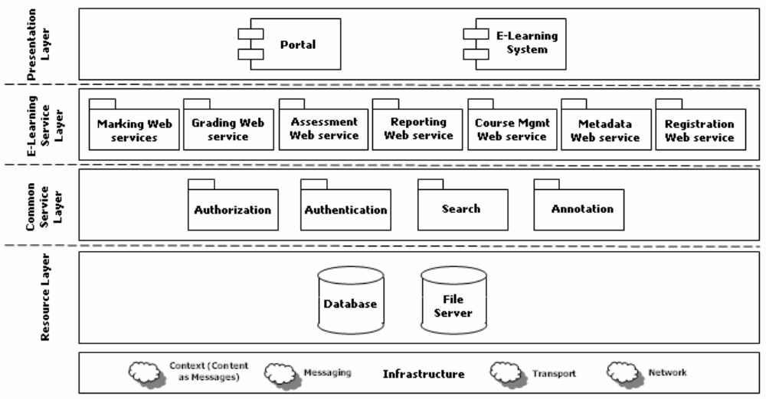
Figure 3: Architecture design of the e-Learning Web services [60]

    - Services based e-Learning Systems and Scalability
Another SOA based framework for e-Learning Systems is presented by Chih-Ping Chu et al. [61]. Chih-Ping Chu et al. addresses the scalability issues of educational institutions and propose a SOA based e-Learning framework to address scalability capabilities of SOA. This research handles the educational institutions incapability of maintaining large scalable LMSs by grouping LMSs services (based on ADL Seven services as depicted below) into local and global groups. Local services group which constitutes the “Local LMS” are provided and maintained internally while other services can be spread over the internet. ADL modularize LMS into seven services: Tracking, Delivery, Learner Profile, Course, Sequencing, Content Management, Testing/Assessment. Chih-Ping Chu et al. argues that tracking and delivery services shall compose local LMS while rest of the services can be spread globally. Authors argue that maintaining learning material might exhaust educational institution resources, so Local LMS will not store learning material, however it will acquire it from different places.
LMS is described as a highly generalized model consisting of seven parts that provide the functionality of learner/learning tracking, content delivery, course import/export and content sequencing:
- Tracking service: takes a learner request and traces the learning status of the learner. It is the LMS entry point for a user to request learning content, and invoke related services, according to that request. It also has the responsibility of tracking the learning process and the learner’s keystrokes or mouse clicks and whether they abort the learning process. Figure 4 presents the Tracking and Remote Web service [61].
- Delivery service: delivers the learning content to the learner. It is better from performance view to keep both tracking and delivery services both on the same server. Besides, static binding between services will enhance the performance of the learning process.

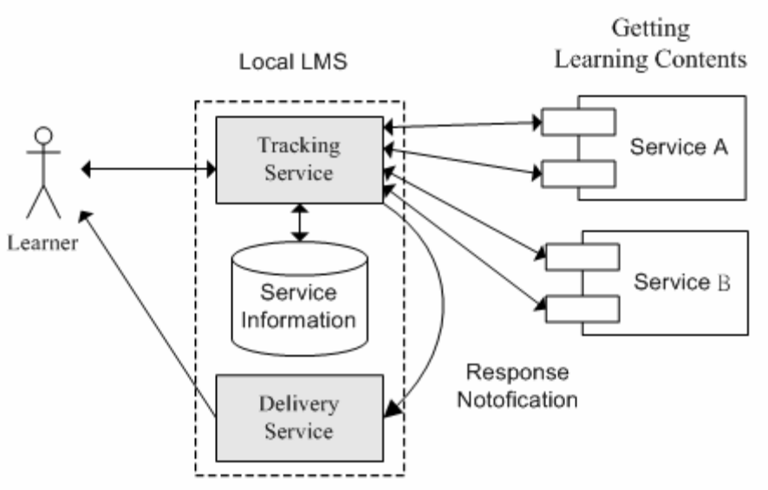
Figure 4. Tracking and Remote Web service [61]

- Learner Profile service: sharing user profile between different LMSs is a goal here (because users can be learning via different LMSs). Standardization of learner profiles is important. Authentication between LMSs is required before receiving user profiles. Figure 5 presents User profile service [61].
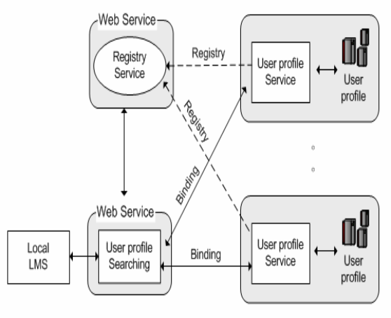
Figure 5. User Profile Service [61]
- Sequencing service: during the learning processing, selects the appropriate content from either the local content repository or a remote content provider. Remote content providers register their content information with the Register server. In proposed framework, there is no local content repository, and all content is supplied by content providers. The sequencing service retains information about the content provider and learning process, since there is no guarantee that a tracking service will bind with the same sequencing service as the learning progresses. Figure 6 presents Operation of Sequencing Service [61].
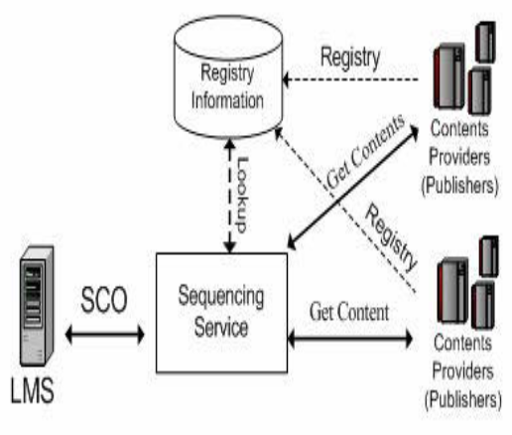
Figure 6. Operation of Sequencing Service [61]
- Course/Content Management service: selects content and provides it to the sequencing service. Figure 7 depicts the Sequence Service and Content Providing Service.

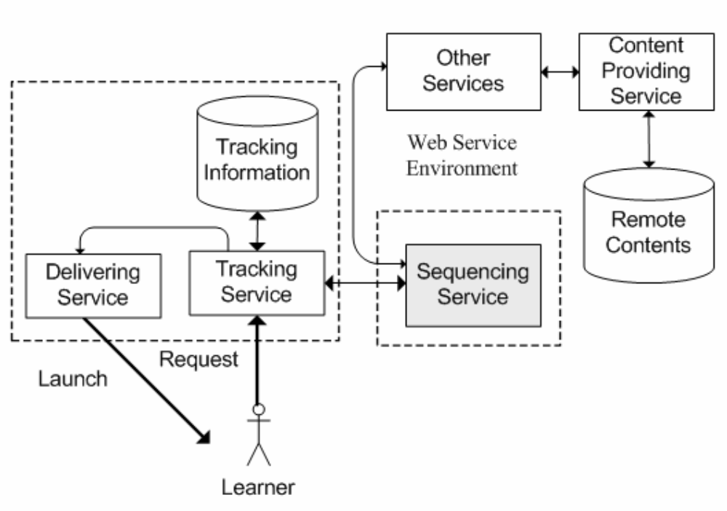
Figure 7. Sequence Service and Content Providing Service [61]

Chih-Ping Chu et al. presents a great work from our perspective. Though proposed framework combined content with course services to be almost one service, and though they did not mention Assessment/Test service at all, they still presented a SOA based e-Learning framework that included modifications to the Original ADL LMS model to fit with the research objective.
    - Services based e-Learning Systems and Integration
Zhengfang Xu et al. [62] propose a Web services oriented framework for e-learning systems aimed at providing a flexible integration model in which all the learning components and applications are well defined, effectively discovered, and loosely connected through using Web services as the main system component to achieve that objective. However, Zhengfang Xu et al. argues that there is a need for a standard mechanism for supporting complete automation through all aspects of end-to-end learning process that includes finding suitable learning components or learning management services, getting information about their services and invoking their services. Though automation of complete end-to-end learning process might seem to be a goal to achieve, doubts about the effectiveness of such a learning approach is under questions. Arguments that prove the efficiency and effectiveness of pure e-Learning programs are not completely confirmed. There is a need of human tutor to support blended learning (at least at some level of the learning process). This research did not include any details about evaluation of the proposed work. Experience proved to us that SOA is not just Web services. Evaluation of utilizing SOA in integrating LMS and UMIS is available in details. Though we don’t completely agree with this research project, however it still confirms the need to present Web services to LMSs to gain advantages like flexibility, and accessibility, and overcome challenges like integration and interoperability.
Another SOA based e-Learning research project is the one presented by A. M. Riad and H. A. El-Ghareeb [26] that presents a SOA based Course Management System (CMS) to address different integration challenges. One of the critical limitations of a newly established educational institution is the lack of available well prepared courses. It is more applicable to use widely available courses that might be higher in quality than preparing new courses. Current CMSs do not exploit courses shareability. To address this shortage, a CMS is presented to highlight automated discovering and importing of courses maintained and managed by external CMSs. Proposed CMS architecture utilizes SOA as a design pattern to integrate different CMSs on service level. Proposed CMS consists of two layers: Presentation layer and Service Layer. Presentation layer is responsible for interacting with user either via displaying information or receiving user inputs. Service layer contains core system services. Service layer is divided into three sub layers: orchestration layer, application services layer, and agents layer. Orchestration layer holds business logic required by system processes. Application services layer contains set of stateless services that are capable of performing certain tasks. Agents layer presents the suggested required software agents to serve the overall system. Suggested agents are: Discoverer, Ranker, Tracker, and Analyzer software agents. Integration between software agents and Web services is achieved by utilizing SOA. Proposed CMS facilitates integration between different CMS in order to share resources of educational institutions.
Other SOA based e-Learning research projects that concern integration is the one presented by Michel Derntl and Juergen Mangler [63]. Michel Derntl and Juergen Mangler argues that Web services have drawn the attention of learning technology researchers and practitioners, e.g., for decentralized, integrated support of Web-service-based agents, for contract-based provision and discovery of distributed Reusable Learning Object (RLO) repositories, or for enhancing the functionality and interoperability of existing learning technology applications, to mention a few. All of these approaches employ Web services to increase extensibility and flexibility of existing solutions and to foster standards-driven development, dissemination, and usage of desired functionality. They presents an open, standards-based learning technology architecture that uses distributed Web services to support a broad variety of blended learning scenarios and administration asks. This project addresses blended learning where; according to the author, not much projects address efficiently. SOA has been adopted in different ways in different e-Learning projects and from different perspectives, and there is much research to be done regarding this point to highlight the advantages and shortages of SOA within e-Learning domain.
    - Services based e-Learning Systems and Interoperability
“Scalable Adapter” design pattern constitutes a software architecture that can be used to create interoperability between differently targeted educational tools. The key idea behind the pattern is to add a small “data adapter” to each learning environment. The adapters can then access arbitrary (scalable) parts of the data of “their” learning environment and exchange this data with other adapters. These changes are not costly and usually easy to create since the existing systems do not have to be changed but merely need to be extended. This design pattern is used mainly to provide interoperability features between different e-Learning tools used in educational institutions. Advantages of this design pattern are many and three different case studies presented in this research. However, integrating different applications on data level has never been the appropriate solution for all system integration problems.
Andreas Harrer et al. presented an interoperability approach based on data [64]. There are driving forces for applying that approach, include: easier exchange of data, reduced development time, and reduced maintenance costs. Architects and programmers do not have to change current already running systems; instead they need to add new adapters that connect systems together. However, connecting systems together via adapters is not “always” the optimum solution. Data based interoperability lacks application logic interoperability and might stand as an obstacle against Business Processes adoption within educational institutions. However, data based interoperability cannot be ignored.
Another SOA based interoperability research project is the one presented by A. M. Riad and H. A. El-Ghareeb [65]. This research project presents a SOA based Assessment Management System (AMS) to address Mobile Assessment as one of the e-Learning activities. Mobile Learning (M-Learning) is an approach to E-Learning that utilizes mobile devices and is strongly recommended to be enabled by LMS. Assessment is one of the learning activities that can be achieved electronically and via mobile devices. Mobile assessment refers to the capability of conducting assessments via mobile devices. Mobile assessment relies on external services that are not part of the LMS. Providing interoperability between different external systems and services to be virtually part of the educational institution LMS is one of integration and interoperability challenges. Authors presented an extension to the SOA based LMS developed in the faculty of computers and information systems at Mansoura University to address mobile assessment. Proposed architecture consists of two layers: Interface layer, and Service layer. Interface layer interacts with instructors, learners, and business managers via human interface (portals), and with external organization services via machine interface (Web services). Service layer contains core LMS services and has three sub layers: Orchestration, Application Services, and Agents layer. Orchestration layer holds business logic presented by system processes as executable services. Application Services layer contains set of stateless Web services that are capable of performing certain tasks related to system entities. Agents’ layer presents the suggested required software agents to serve the overall system. Agents’ layer presents Tracker software agent; which is responsible of tracking students’ non-conducted assessments and taking appropriate actions to inform them.
Other interoperability approach that acts on “service basis” is presented by Pedro J. Muñoz-Merino et al. [66]. Pedro J. Muñoz-Merino et al. highlights the importance of standards and its role in interoperability between different applications. Also, they argue that layering is one of the patterns that are important while considering e-Learning solutions. Also, LMSs’ future tendency is to be service-oriented. In this scenario, LMSs are based on modular components and they can support different services that do not stick to a specific platform. They envision that the ideal scenario is one in which all the different educational services can be interoperable among different LMSs; and in which the entire design of different LMS courses can be done off-line (outside of LMSs) in an easy way for teachers without high technological knowledge using proper authoring tools’ and next these courses can be imported within the different LMSs. Based on OKI architecture depicted in figure 8, they present their architecture.
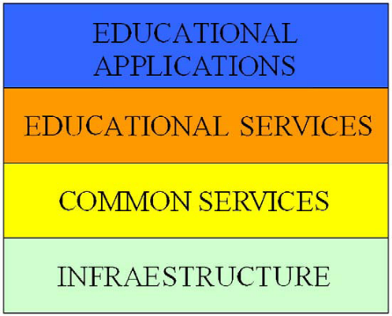
Figure 8. OKI Layered Architecture (Pedro J. Muñoz-Merino et al. 2009)
Infrastructure layer represents the final resources of an institution, such as file systems or databases. The Common Services are services that are used by several educational applications, such as authorization or authentication. The Educational Services are specific educational modules like assessment or Course Management. Finally, the Educational Applications are the applications a user directly interacts with and these educational applications can use the implemented educational and common services. The IMS Abstract Framework architecture is very similar to the defined by OKI, and a perfect relationship among layers of both architectures can be established. Both architectures capture the strong importance of LMS services. Besides interoperability, Reusability of courses, services, and all other materials is one of the main motivators of researchers to highlight the importance of layering and standards to achieve interoperability and reusability between different distance educational systems.
    - Services based e-Learning Systems and XML
Theodre K. Apostolopulos and Anna Kefala propose an e-Learning framework based on the design and implementation of a middleware [67]. Authors ought to adopt technologies that are standardized and widely deployed in both e-Learning systems and network infrastructure layers. The general architecture of the e-Learning management scheme is based on the configurable component-based middleware architecture for deploying e-Learning services. Each component has one or more agents, which maintain a local XML-based Management Information Base (MIB), and communicate with manager residing at the service or session management component. The agent communicates with the middleware via a light protocol such as SOAP.
Another research project that utilizes XML in e-Learning is the one presented by Wan-Jen-Chang et al. [68]. Wan-Jen Chang et al. proposed an e-Learning platform with the required functions to provide information to everyone in anytime and at anywhere. The three functionalities are:
- Learning contents presented by vision (i.e., Web browser) and voice (i.e., voice device, phone, cell phone) to provide learners who are less technology-literacy and visually disabled to join learning.
- KMLS associates with collaborative learning (i.e., learning communities) to transform tacit knowledge into explicit knowledge by consultation, assessment, discussion and sharing experiences.
- The subject of life education is everyone needs to face and to develop unrestrained by age, gender, and avocation.
Utilizing VoiceXML to support Voice User Interface (VUI) was a powerful idea and the integration presented between different system components via XML utilization was a good contribution.
  - Comments on Services based e-Learning Systems
SOA utilization from different researchers’ perspectives leads to different SOA based e-Learning systems architectures. From full SOA functionalities architectures to just Web services enabled architectures are available by different researchers. SOA based e-Learning systems frameworks are available; without much evaluation and further analysis of points of strength and weaknesses. Architectures that tend to support fully automated learning process and architectures that tend to support blended learning are available. SOA based systems that support point-to-point integration and interoperability, and architectures that support Middleware based integration and interoperability also exist. Each approach has its own points of strength and points of weakness. Point-to-point integration enhances performance. On the other hand, middleware based architectures are more flexible, scalable, and fault tolerant. Evaluation of utilizing SOA in e-Learning systems need to be more studied to highlight advantages and shortages of utilizing SOA in e-Learning, and still SOA based architectures vary a lot from a research project to another.
- Conclusion
In 2003, Charles A. Shoniregun, and Sarah-Jane Gray [69] wondered if e-Learning is a risk or a future, and we believe that e-Learning is an important part of the future that depends on how e-Learning researchers and application designers will present to support and enhance. By surveying e-Learning research activities in the last decade, it is clear that e-Learning has been presented to everyone, and challenges have moved to a next step: the step of efficiency and effectiveness. Either e-Learning has achieved the required results or has not yet, that only means e-Learning researchers are facing new challenges. Adaptive e-Learning is one of the proposed solutions to exploit the unlimited advantages of e-Learning. Tutoring is a solution to learning limitations and challenges and Intelligent Tutoring Systems have been a reputational research subject [70]. E-Learning can present fined adaptive e-Learning solutions supported by the intelligent methods and techniques presented over long time of research. Services based learning systems represent the third generation of learning systems that supports integration, interoperability, and scalability. Services based Learning Management Systems are recommended in order to fulfil e-Learning systems architectural requirements. Adaptive e-Learning that is supported by intelligent techniques is the proposed solution to present efficient and effective learning. To the knowledge of the authors, there is no article have been found to merge adaptive and intelligent techniques with SOA in the subject of e-Learning. As a result, we were concerned with our activity to fill this gap.
- References
    - Zongmin Ma, "Web-Based Intelligent E-Learning: Technologies and Applications", Information Science Publishing, 2006

    - Willam Horton, Catherine Horton, “E-Learning Tools and Technologies”, Wiley Publishing Inc., 2003

    - Michael Graham Moore, “Handbook of Distance Education”, Lawrence Erlbaum Associates, 2003

    - Charles D. Dziuban, Joel L. Hartman, Patsy D. Moskal, “Blended Learning”, Vol. 2004, Issue 7, Educase Connect, 2004

    - D. Randy Garrison, and Heather Kanuka, “Blended learning: Uncovering its transformative potential in higher education”, The Internet and Higher Education, Volume 7, Issue 2, 2nd Quarter 2004, pp. 95-105.

    - Sandy Britain, Oleg Liber, “A Framework for Pedagogical Evaluation of Virtual Learning Environments”, JTAP - JISC Technology Application Programme, University of Wales - Bangor, 1999

    - Alfred Bork, Carole A. Bagley, Xiwen Zhang, “Technology and Learning: A proposal for Adaptive Learning Tutorial”, Michael Allen's 2008 e-Learning Annual, J-B Pfeiffer Annual Looseleaf Vol1, 2008.

    - James Ong, Sowmya Ramachandram, “Intelligent Tutoring Systems: Using AI to improve Training Performance and ROI”, Stottler Henke Associates Inc., 2003

    - D. G. Moursund,” Introduction to Information and Communication Technology in Education”, David Moursund, 2005.

    - Felix Modritscher , Victor Manuel Garcia-Barrios , Christian Gütl, "The Past, the Present, and the Future of adaptive E-Learning", Proceedings of the International Conference on Interactive Computer Aided Learning (ICL2004), 2004

    - N. Matar, S. Khwaldeh, Z.Hunaiti, “Adaptive Unified E-learning System for Supporting Better
E-learning Approach”, The 8th Annual Postgraduate Symposium: The Convergence of Telecommunications, Networking and Broadcasting, Liverpool Johm Moores University, 2007

    - Peter Brusilovsky, "A Distributed Architecture for Adaptive and Intelligent Learning Management Systems", Proceedings of the AIED 2003 Workshop Towards Intelligent Learning Management Systems, Sydney 2003

    - Daniel Burgos, Colin Tattersall, Rob Koper, “Representing adaptive and adaptable Units of Learning. How to model personalized eLearning in IMS Learning Design”, CELSTEC Research on Learning Networks, Open Universities, Netherland, 2006

    - Natalia Stash, "Incorporating Cognitive/Learning Styles in a General-Purpose Adaptive Hypermedia Systems", SIKS, 2007

    - Christian Gutl, Victor Manuel Barrios, Felix Modritscher, “Adaptation in E-Learning Environments through the Service-Based Framework and its Application for AdeLE”, IDC: US Corporate and Government eLearning Forecase, 2003

    - John Eklund, Peter Brusilovsky, Elmar Schwarz, “Adaptive Textbooks on the World Wide Web”, Third Australian World Wide Web Conference, Southern Cross University, 1997

    - E. Espinosa, V. Robledo-Rella, L. Neri, J. Noguez, “Towards an adaptive delivery of evaluation tools”, Frontiers in education conference, FIE apos; 07, 37th annual, 2007

    - Alexandros Paramythis, Susanne Loidl-Reisinger, “Adaptive Learning Environments and
e-Learning Standards”, Electronic Journal on e-Learning, Volume 2, Issue 1, 2004

    - Alfred Kobsa, Jurgen Konemann, Wolfgang Pohl, "Personalized Hypermedia Presentation Techniques for Improving Online Customer Relationships", The Knowledge Engineering Review, Volume 16, 2001, pp. 111 – 155

    - Peter Brusilovsky, “Methods and Techniques of Adaptive Hypermedia”, User Modeling and User-Adapted Interaction: 6, Kluwer Academic Publishers, 1996.

    - Peter Brusilvosky, “Adaptive Hypermedia”, User Modeling and User-Adapted Interaction: 11, Kluwer Academic Publishers, 2001.

    - Christopher Bailey, WendyHall, David E. Millard, MarkJ.Weal, “Towards Open Adaptive Hypermedia”, Proceedings of the Second International Conference on Adaptive Hypermedia and Adaptive Web Based Systems, Malaga, Spain, 2002.
    - Miikka Miettinen, Jaakko Kurhila, Henry Tirri, "On the Prospects of Intelligent Collaborative E-learning Systems", The 12th International Conference on Artificial Intelligence in Education (AIED 2005), Finland, 2005.

    - Ioannis Hatzilygeroudis, Constantinos Koutsojannis, Constantinos Papavlasopoulos, Jim Prentzas, "Knowledge-Based Adaptive Assessment in a Web-Based Intelligent " Educational System, Proceedings of the Sixth IEEE International Conference on Advanced Learning Technologies (ICALT), 2006

    - Christopher Paul Bailey, “An Agent-Based Framework to Support Adaptive Hypermedia”, Departments of Electronics and Computer Science, Faculty of Engineering, University of Southampton, United Kingdom, 2002

    - A. M. Riad, H. A. El-Ghareeb, “A Service Oriented Architecture to Integrate Web services and Agents in Course Management Systems”, Egyptian informatics Journal, Cairo University, 2007, Vol. 8, Issue 1, 2007.

    - e-Learning Engineering, http://www.elearning-engineering.com/ai.htm, 2006

    - Dunwei Wen, Fuhua Lin, "Ways and Means of Employing AI Technology in E-Learning Systems" icalt, Eighth IEEE International Conference on Advanced Learning Technologies, 2008, pp.1005-1006

    - David J. Steinhart, “Summary Street: An Intelligent Tutoring System for Improving Student Writing Through the Use of Latent Semantic Analysis”, Faculty of The Graduate School of the University of Colorado, 2001

    - SRI Consulting Business Intelligence, http://www.sric-bi.com/Explorer/NN.shtml, 2004

    - J.E. Villaverde, D. Godoy, A. Amandi, “Learning Styles' Recognition in E-Learning Environments with Feed-Forward Neural Networks”, Journal of Computer Assisted Learning, v22 n3 p197-206 Jun 2006

    - Mu-Jung Huang, Hwa-Shan Huang, Mu-Yen Chen, “Constructing a Personalized e-Learning System based on Genetic Algorithm and Case-Based Reasoning Approach”, Expert Systems with Applications: An International Journal, 2007

    - Anna Hovakimyan, Siranush Sargsyan, Sergey Barkhoudaryan, “Genetic Algorithm and the Problem of Getting Knowledge in e-Learning Systems”, ICALT: Proceedings of the IEEE International Conference on Advanced Learning Technologies, 2004

    - J. Vrettaros, G. Vouros, A. Drigas, “Development of a Diagonistic System of Taxonomies Using Fuzzy Logic – Case SOLO (useful for e-learning system”, WSEA Transactions on Information Science and Applications, Issue 6, Volume 1, 2004

    - Y. Chen, “Use Feedback and Fuzzy Self-Organizing Map to improve Adaptive e-Learning Model”, World Conference on Educational Multimedia, Hypermedia and Telecommunications (EDMEDIA), 2007

    - K. K. Loo, B. Cheng, “Fuzzy Logic and Data Mining for e-Learning Personalization”, Proceedings of Artificial Intelligence and Applications, ACTA Press, 2003

    - E. Turban, J. E. Aronson, T. Liang,”Decision Support Systems and Intelligent Systems”, Prentice Hall, 2004.

    - Stan Franklin and Art Graesser, “Is it an Agent, or just a Program?:A Taxonomy for Autonomous Agents”, Proceedings of the Third International Workshop on Agent Theories, Architectures, and Languages, Springer-Verlag, 1996.

    - CPS 720, Artificial Intelligence Programming, Ryerson University, Toronto, Canada. http://www.ryerson.ca/~dgrimsha/courses/cps720/index.html

    - T. Finin, “KQML as an Agent Communication Language”, 3rd International Conference on Information and Knowledge Management (CIKM'94), 1994.

    - M. R. Genesereth, “draft proposed American National Standard (dpANS)”, Knowledge Interchange Format, NCITS.T2/98-004

    - S. Virdhagriswaran, D. Osisek, O'Connor, “Standardizing agent technology”, ACM Press, 1995, Vol. 3.

    - J. M. Bradshaw, “KAoS: An Open Agent Architecture Supporting Reuse, Interoperability, and Extensibility”, http://ksi.cpsc.ucalgary.ca/KAW/KAW96/bradshaw/KAW.html

    - FIPA: Foundation for Intelligent Physical Agents, http://www.FIPA.org
    - Alfredo Garro and Luigi Palopoli, “An XML Multi-agent System for E-learning and Skill Management”, Agent Technologies, Infrastructures, Tools, and Applications for E-Services , Lecture Notes in Computer Science, Springer, 2003, Pp. 283-294

    - O.R. Zaiane, “Building a recommender agent for e-learning systems”, Proceedings of International Conference on Computers in Education, 2002, Pp.: 55- 59 vol.1

    - Albert T. Corbett, Kenneth R. Koedinger, John R. Anderson, 1997, “Intelligent Tutoring Systems”, Handbook of Human-Computer Interaction, Second, Completely Revised Edition in M. Helander, T. K. Landauer, P. Prabhu (Eds), Elservier Science

    - B. H. Sreenivasa Sarma, B. Ravindran, “Intelligent Tutoring System using Reinforcement Learning to teach Autistic Students”, http://www.cs.iitm.ernet.in/~ravi/papers/Sarma_HOIT_07.pdf

    - Mary A. Mark, Jim E. Greer, “Evaluation Methodologies for Intelligent Tutoring Systems”, Journal of Artificial Intelligence in Education, 1993

    - Edward R. Sykes, Franya Franek,”Web-Based Architecture of an Intelligent Tutoring System for Remote Students Learning to Program Java” , AT&T Labs http://www.research.att.com/~rjana/sykes_franek.pdf

    - David Sprott, Lawrence Wilkes, “Understanding Service Oriented Architecture”, Microsoft Architect Journal. – 2004, Vol. 1., pp. pp. 10-17

    - P. Shodjai, “Web services and the Microsoft Platform”,Microsoft Software Developers Network (MSDN), 2006.

    - D. Booth, “Web Services Architecture”,W3C, 2004.

    - D. Sprott, “A Web service Maturity Model”, CBDI forum, http://roadmap.cbdiforum.com/reports/maturity/maturity2.php

    - M. Gudgin, “SOAP Version 1.2 Part 1: Messaging Framework”, W3C, 2003

    - J. Cowan, R. Tobin, “XML Information Set (Second Edition)”, W3C, 2004
    - X. Zhou, J. Li, H. Shen, M. Kitsuregawa, Y. Zhang, “Frontiers of WWW Research and Development”, Springer, 2006.

    - Declan Dagger, Alexander O’Connor, Séamus Lawless, Eddie Walsh, Vincent Wade, “Service Oriented eLearning Platforms: From Monolithic Systems to Flexible Services”, IEEE INTERNET COMPUTING, 2007

    - Ajlan Al-Ajlan, Hussein Zedan, “E-Learning (MOODLE) Based on Service Oriented Architecture”, De Montfort University, ZDnet White Papers, 2008

    - Moon Ting Su Chee Shyang Wong, Chuak Fen Soo, Choon Tsun Ooi, Shun Ling Sow, “Service-Oriented E-Learning System”, Information Technologies and Applications in Education (ISITAE apos) 2007

    - Chih-Ping Chu Ching-Pao Chang, Chung-Wei Yeh, Yu-Fang Yeh, “A Web-Service Oriented Framework for building SCORM Compataible Learning Management Systems”, International Conference on Information Technology: Coding and Computing (ITCC’04), 2004

    - Zhengfang Xu Zheng Yin, and Abdulmotaleb El Saddik, “A Web Services Oriented Framework for Dynamic E-Learning Systems”, Canadian Conference on Electrical and Computer Engineering; CCECE/CCGEI, 2003

    - Michael Derntl, Juergen Mangler, “Web Services for Blended Learning Patterns”, Proceedings of the IEEE International Conference on Advanced Learning Technologies (ICALT’04), 2004

    - Andreas Harrer, Niels Pinkwart, Bruce M. McLaren, Oliver Scheuer, “The Scalable Adapter Design Pattern: Enabling Interoperability between Educational Software Tools”, IEEE Transactions on Learning Technologies, 2008

    - A. M. Riad, H. A. El-Ghareeb,”A Service Oriented Architecture to Integrate Mobile Assessment in Learning Management Systems”, Turkish Online Journal of Distance Education – TOJDE, April 2008, Volume: 9 Number: 2, Article 12

    - Pedro J. Muñoz-Merino Carlos Delgado Kloos, Jesús Fernández Naranjo, “Enabling Interoperability for LMS educational Services”, Computer Standards & Interfaces, El-Sevier, 2009.

    - Theodre K. Apostolopulos, Anna Kefala, “An XML-based E-learning Service Management Framework”, Proceedings of the IEEE International Conference on Advanced Learning Technologies (ICALT’04), 2004

    - Wan-Jen Chang Hsuan-Hung Chen, Hui-Kai Su, Yuan-Sun Chu, Kim-Joan Chen, “Design of Knowledge Management Learning System based on Service Oriented Architecture”, Proceedings of the Sixth International Conference on Advanced Learning Technologies (ICALT’06), 2006

    - Charles A. Shoniregun, Sarah-Jane Gray, “Is e-Learning Really the Future or a Risk?”, Ubiquity, Issue 10, 2003

    - Brant A. Cheikes, “GIA: An Agent-Based Architecture for Intelligent Tutoring Systems” http://citeseerx.ist.psu.edu/viewdoc/summary?doi=10.1.1.25.2930

Biography


Prof. Dr. A. M. Riad, Head of Information Systems Department, Faculty of Computers and Information Sciences, Mansoura University, Egypt, Web site: http://www.amriad.com


Hamdy K. El-Minir, Head of Communications Department in Misr Engineering and Technology Institute, Mansoura, Egypt. Associate Professor at National Research Institute of Astronomy and Geophysics, Helwan, Egypt.

Haitham A. EL-Ghareeb, Associate Teacher; Information Systems Department, Faculty of Computers and Information Sciences, Mansoura city University, Egypt. Information about publications, activities, and personal blog are available at the Web site: http://www.helghareeb.net

Moodle: an Open Source Learning Management System. Stands for: Modular Object Oriented Dynamic Learning Environment. Official Moodle website: http://moodle.org/
ELF: E-Learning Framework, an international effort to develop a service-oriented approach to the development and integration of computer systems in the sphere of learning, research and education administration. Official Website: http://www.elframework.org
ADL: Advanced Distributed Learning, established in 1997 to standardize and modernize training and education management and delivery. The Department of Defense (DoD) Office oversees the ADL initiative. official Website: http://www.adlnet.gov
OKI: Open Knowledge Initiative, an organization responsible for the specification of software interfaces comprising a SOA based on high level service definitions. Official Website: www.okiproject.org

